**CHAPTER 5: RESULTS AND DISCUSSIONS**

**SNAPSHOTS OF THE MODULES OF THE SYSTEM**

**1.1 LOGIN AND SIGNUP PAGE**

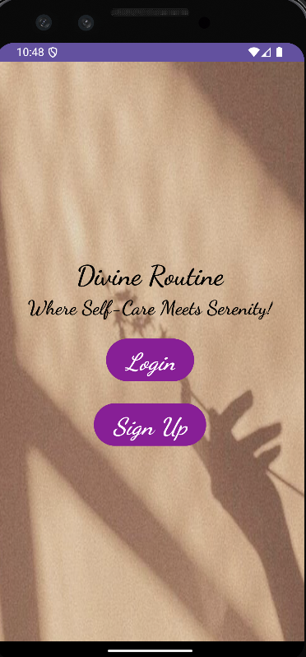 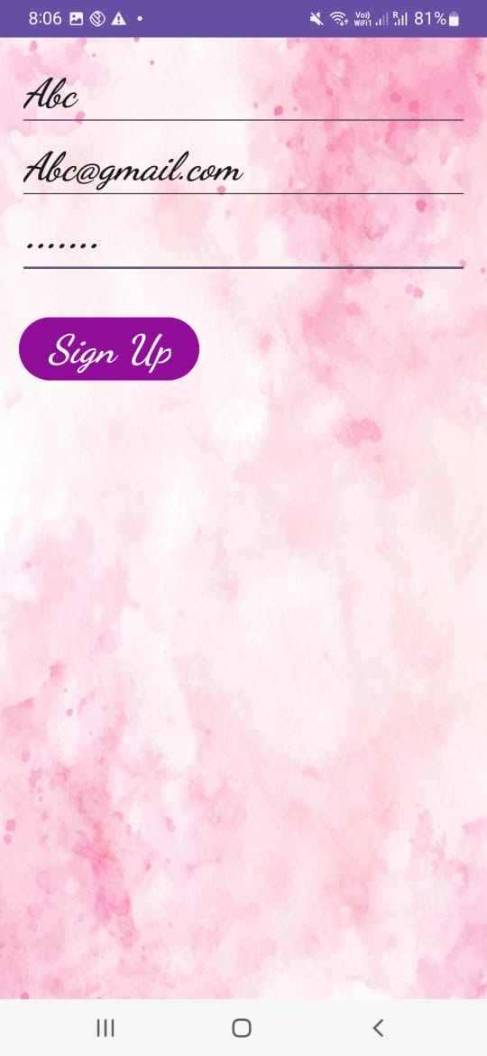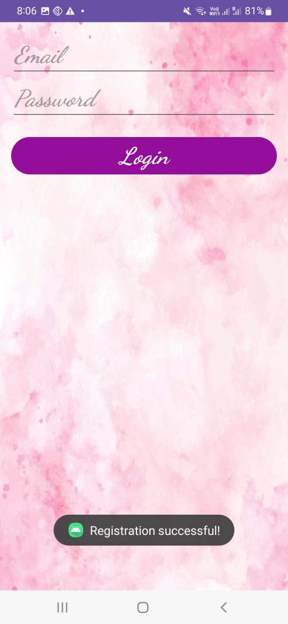

**1.2 HOME PAGE -> SKIN TYPE ROUTIN ->QUESTIONNAIRE**

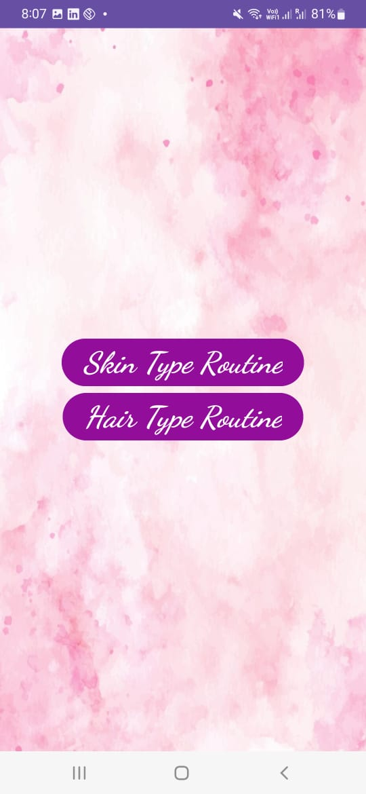 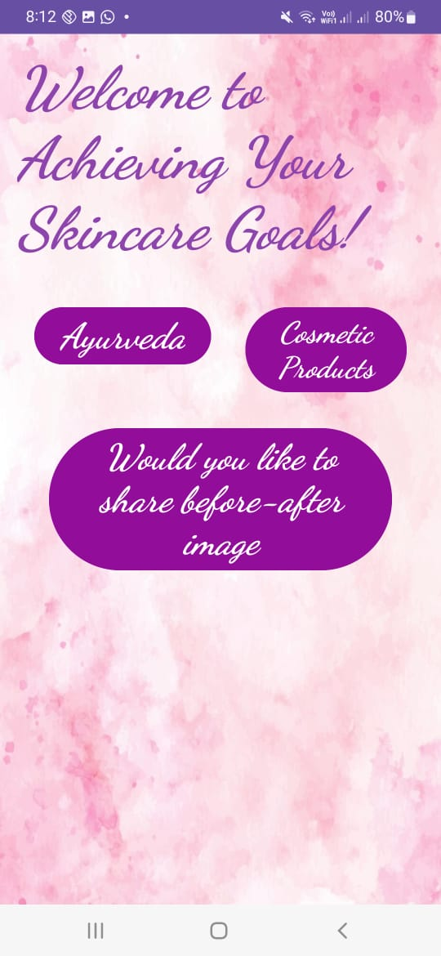 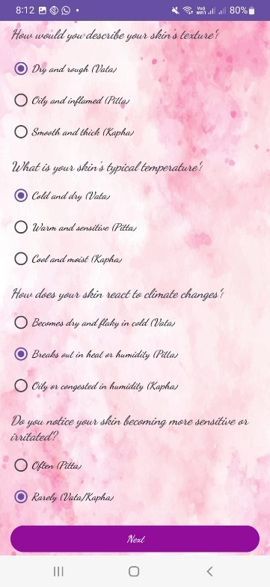

**1.3 QUESTIONNAIRE PAGES-> FINAL SKIN CARE ROUTINE PAGE**

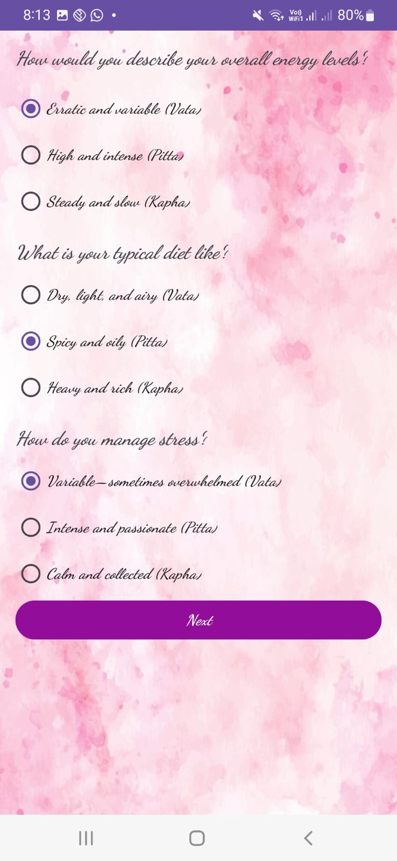 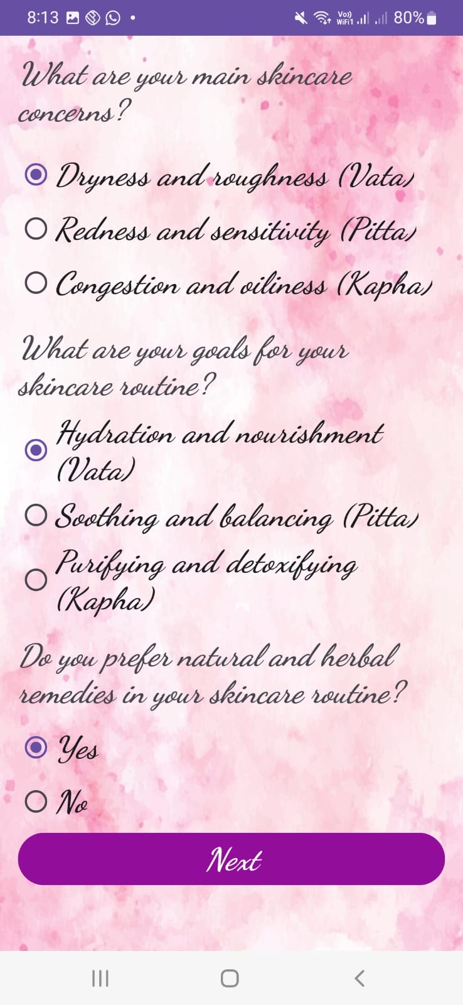 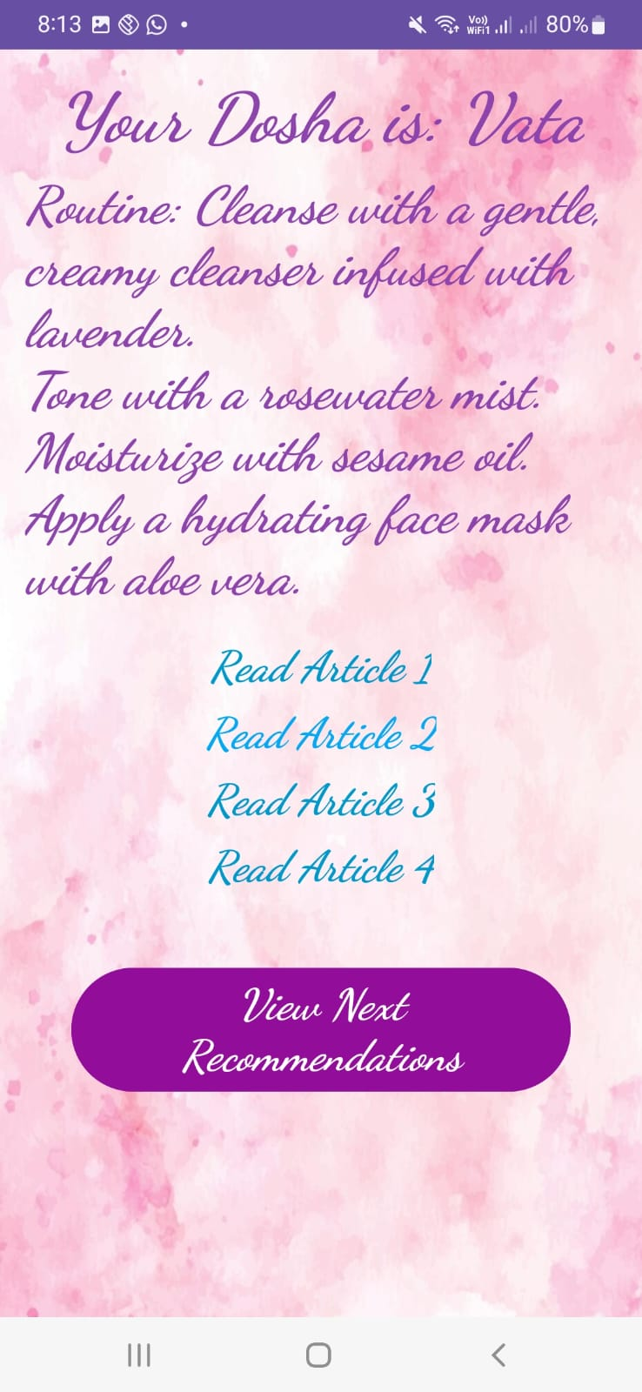

**1.4 ARTICLES-> SHARE MY ROUTINE -> HOME PAGE**

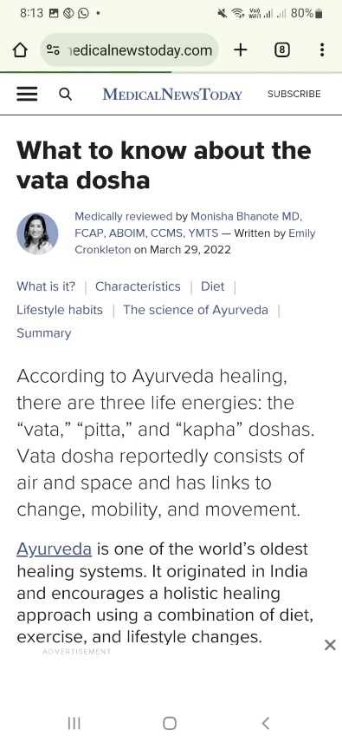 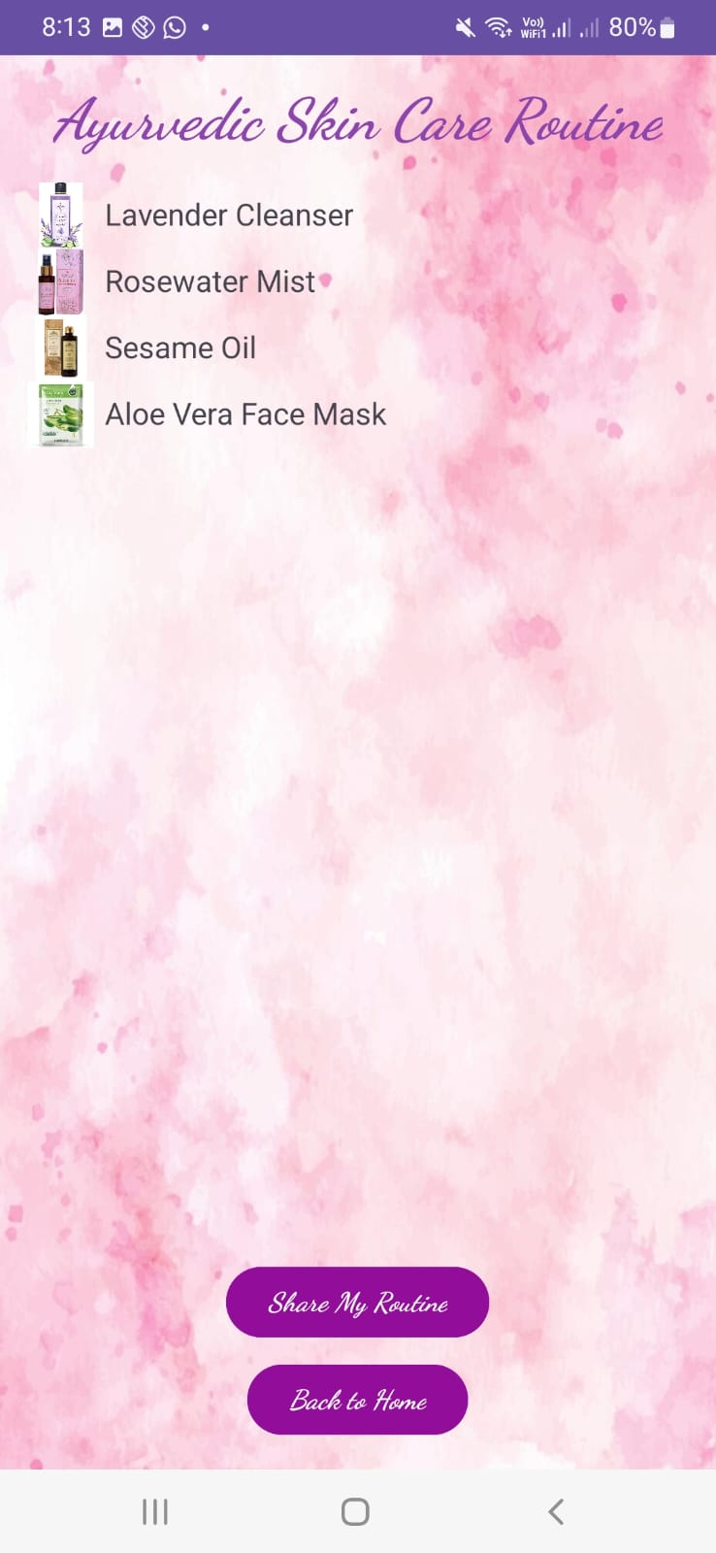 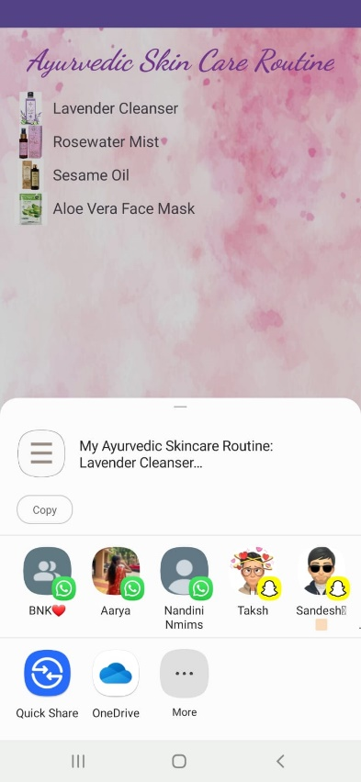

**1.5 COSMETIC PRODUCTS(DAYTIME OR NIGHTIME ROUTINE)->DAYTIME-> QUESTIONARY-> FINAL DAYTIME ROUTINE (SAME FOR NIGHTIME ROUTINE)**

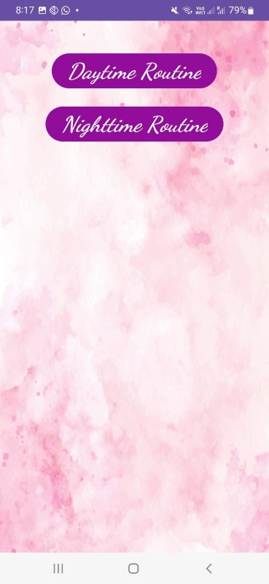 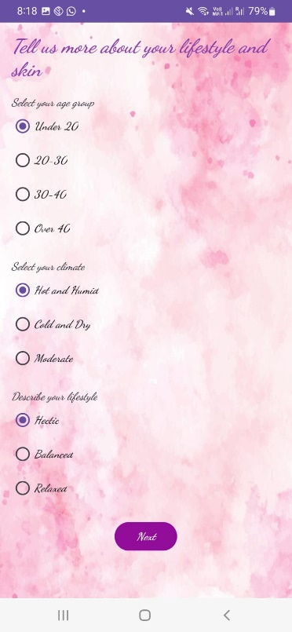 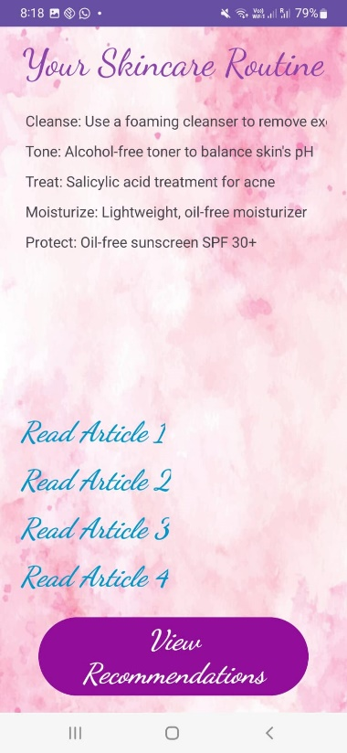

**1.6 VIEW RECOMMENDATION-> BACK TO HOME PAGE**

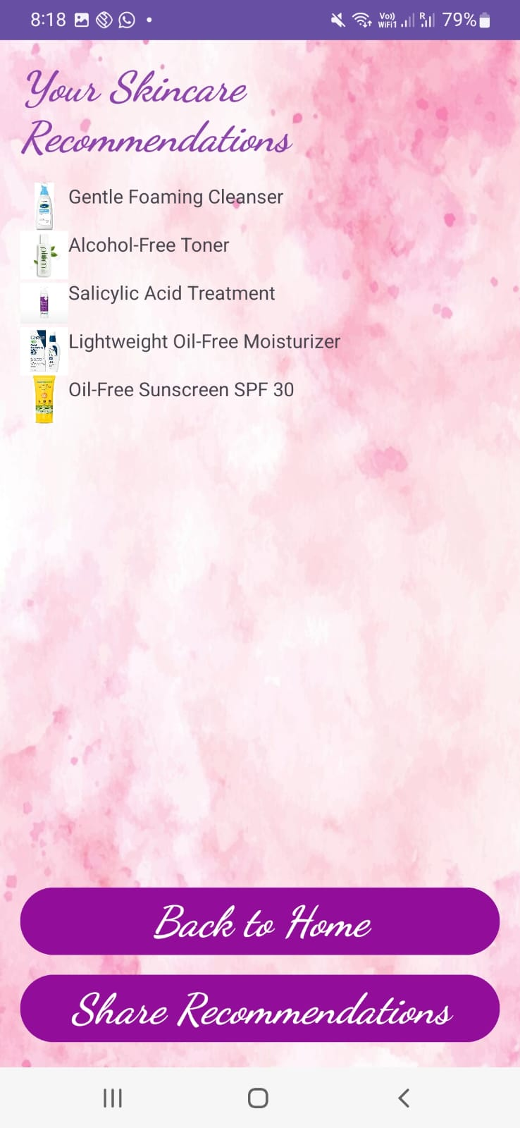

**1.7 HAIRCARE ROUTINE -> AYURVEDA ->QUESTIONARY (WITH ALLERGIC FILTER )**

 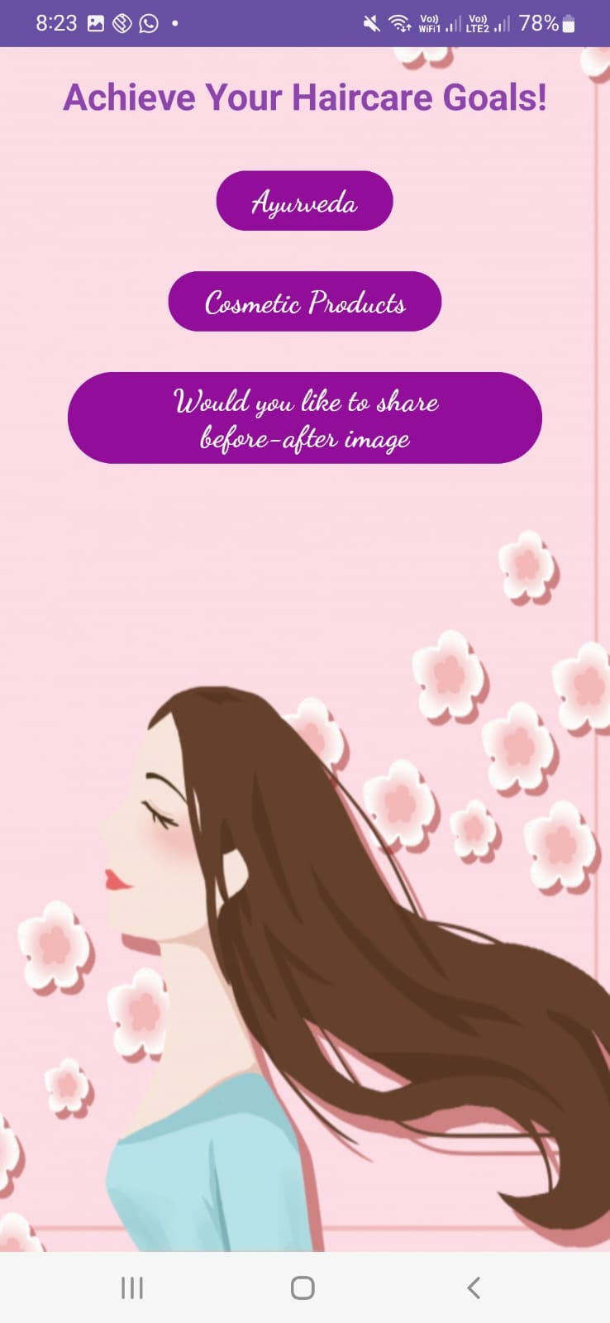 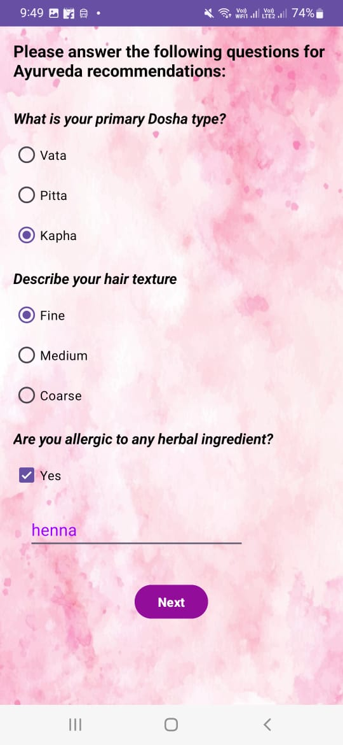

**1.8 RECOMMENDED AYURVEDA PRODUCTS ->FINAL HAIR CARE ROUTINE ->ARTICLES**

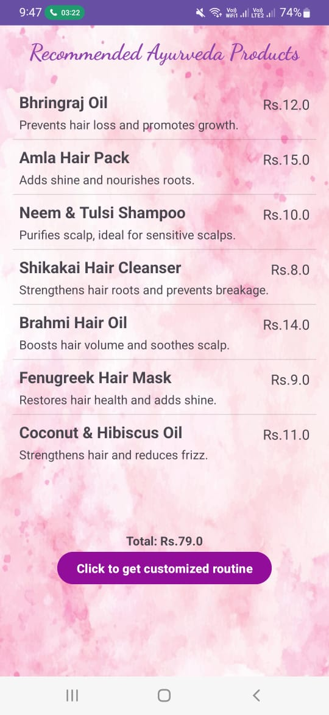 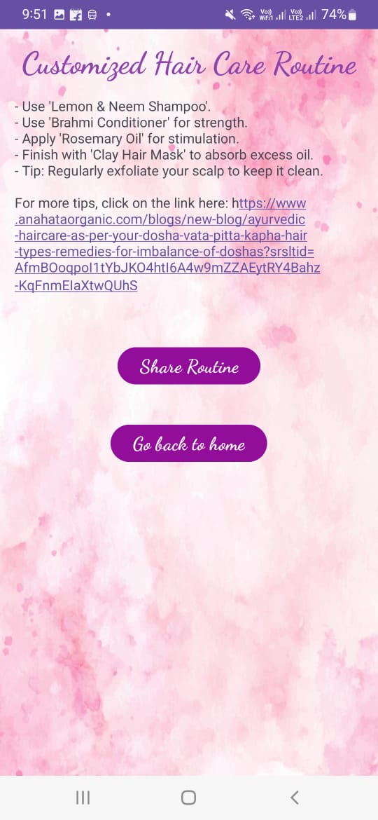 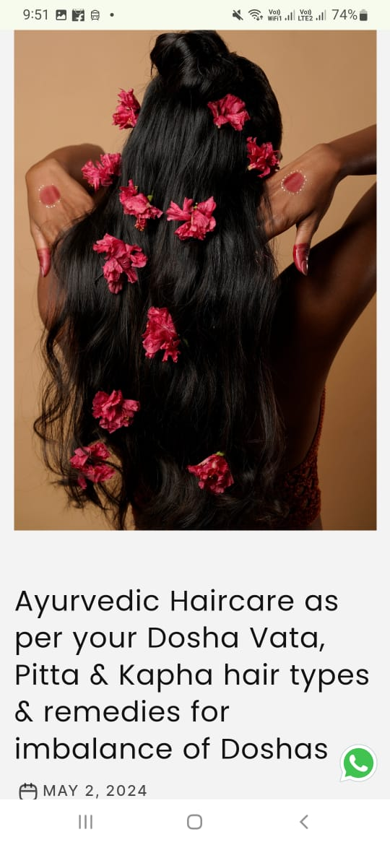

**1.9 QUESTIONARY -> RECOMMENDED AYURVEDA PRODUCTS((WITH ALLERGIC FILTER ) ->HAIR ROUTINE**

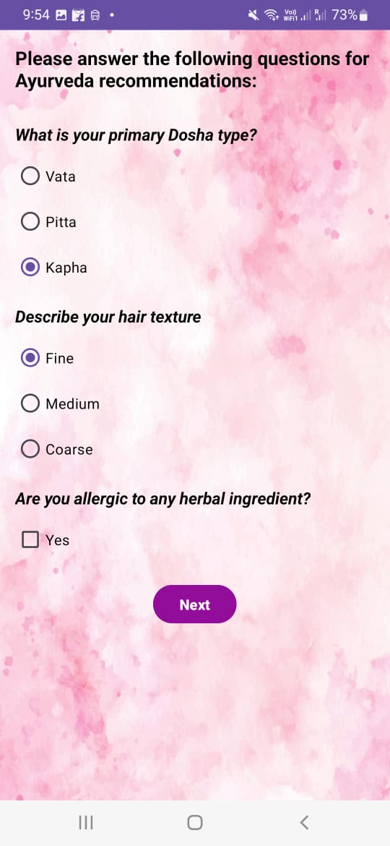 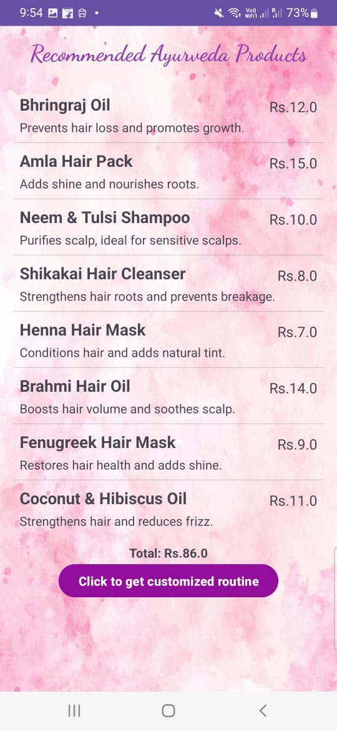 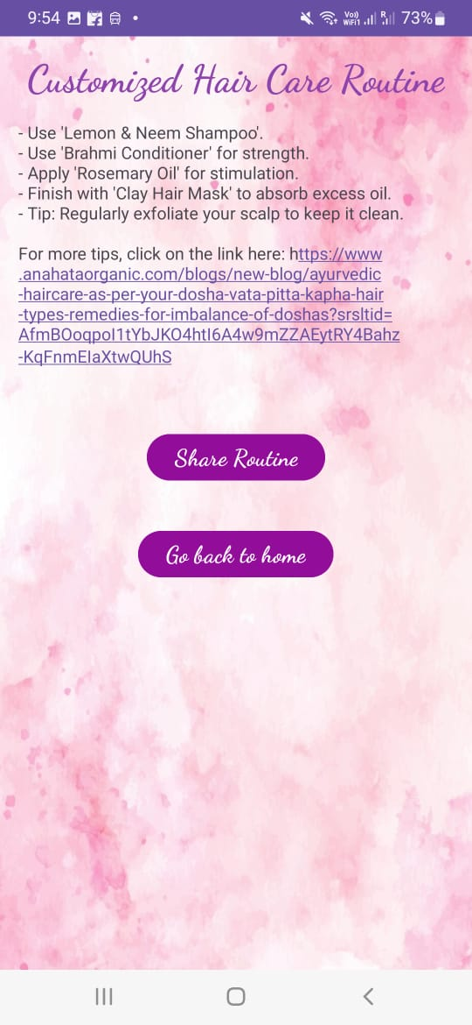

**1.10 SHARE ROUTINE -> BACK TO HOME PAGE**

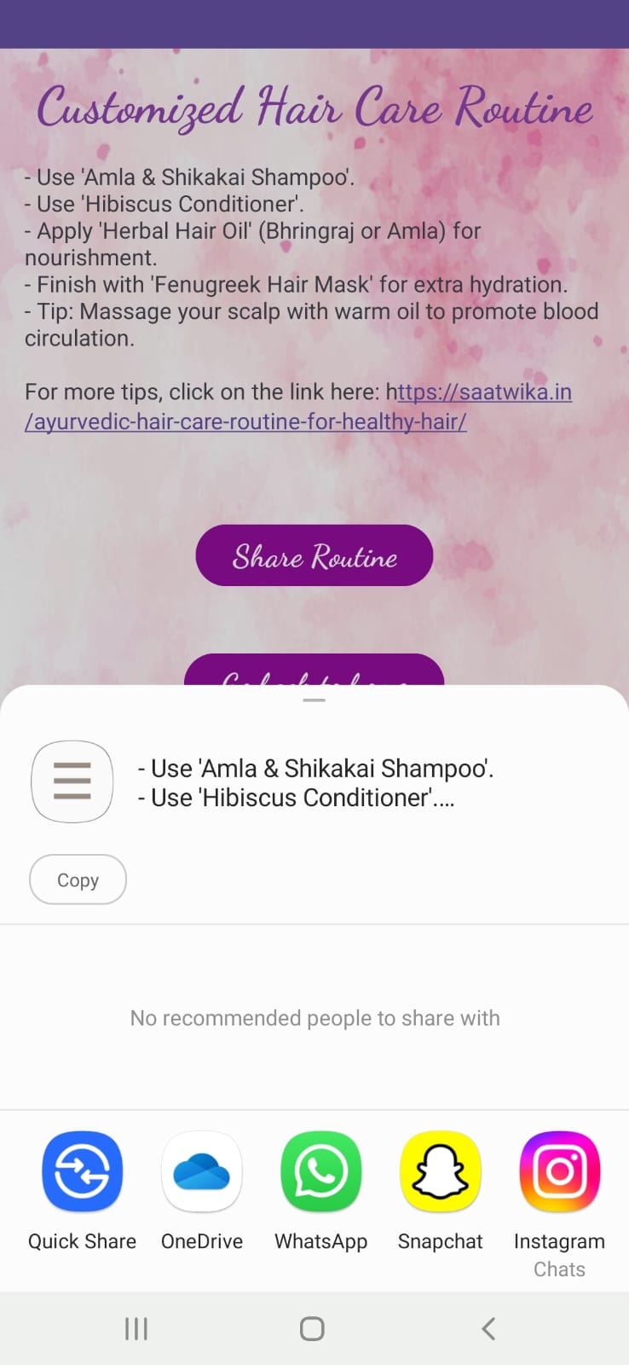

**1.11 COSMETIC PRODUCTS ->QUESTIONARY -> RECOMMENDED COSMETIC PRODUCTS ->FINAL HAIR CARE ROUTINE**

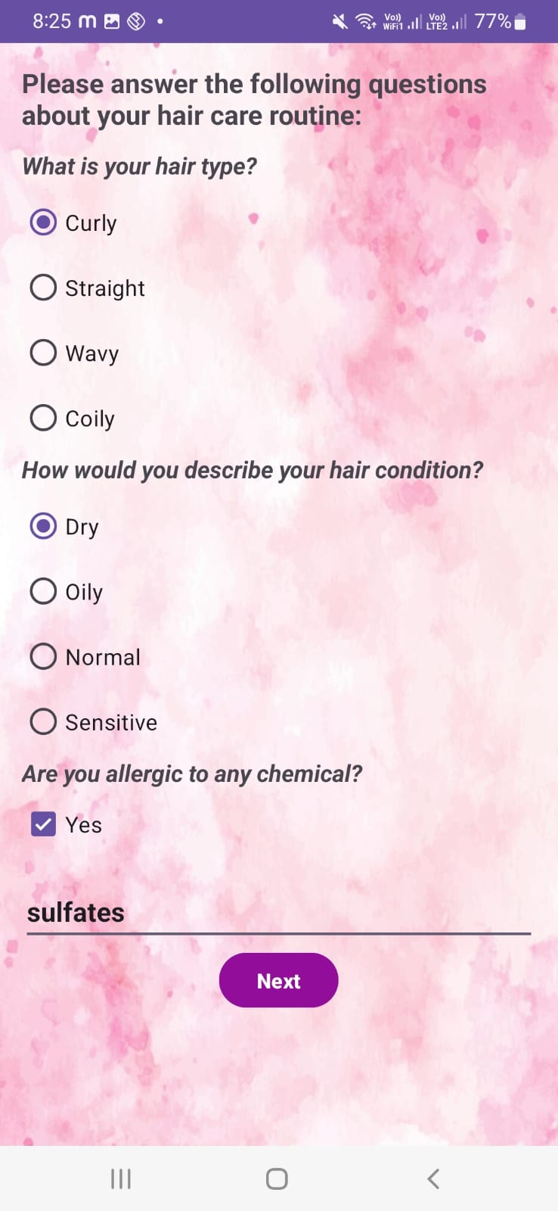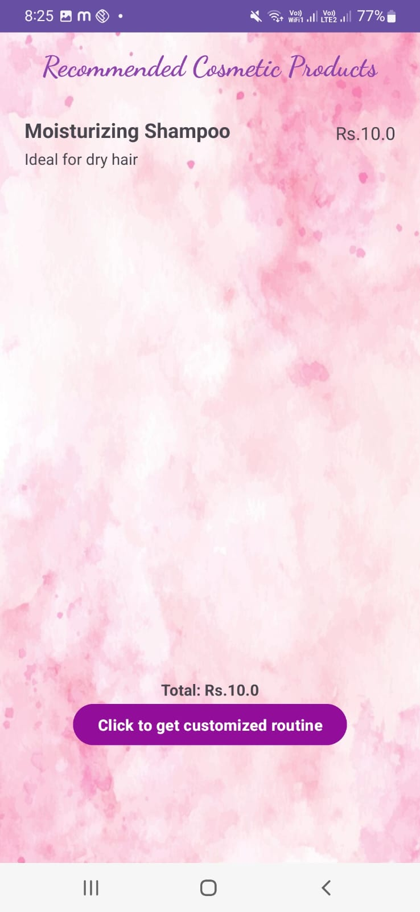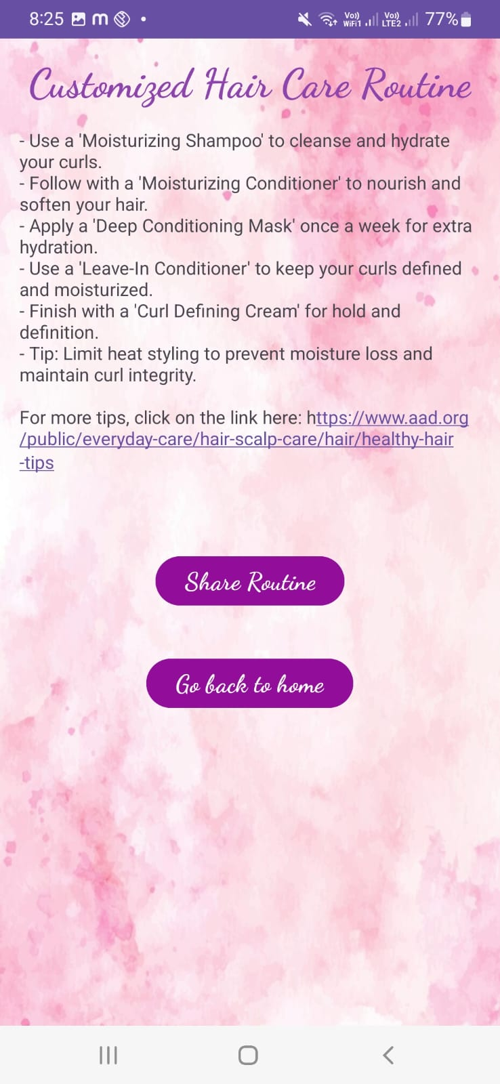

**1.12 ARTICLES-> CAPTURE IMAGE FOR FEEDBACK**

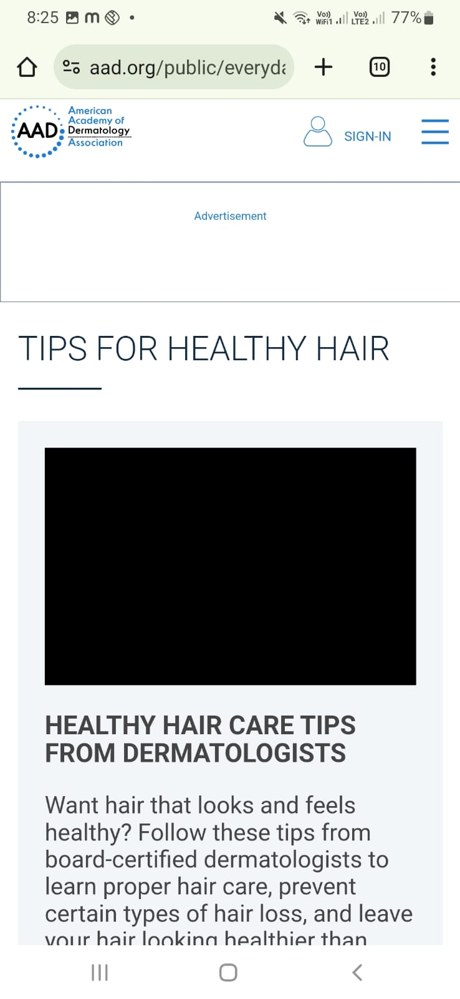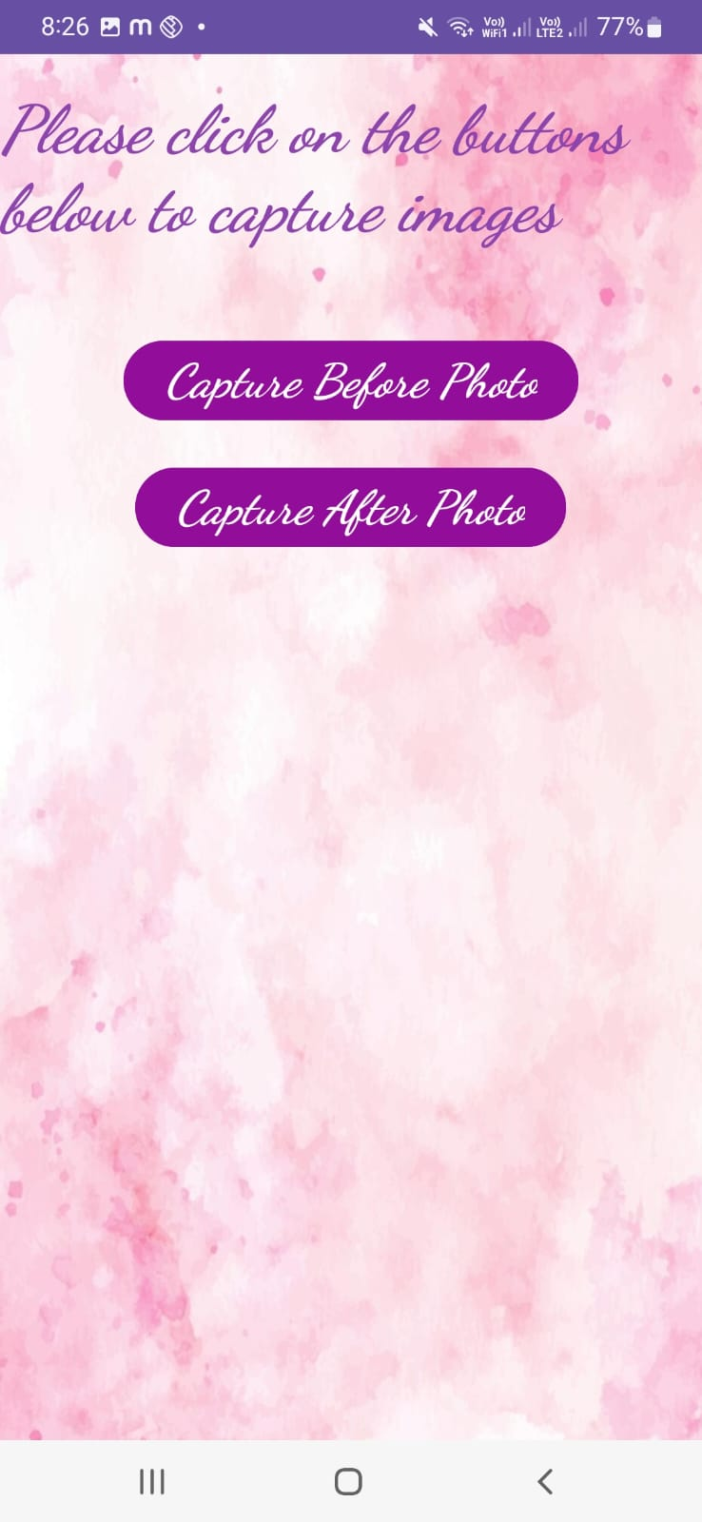 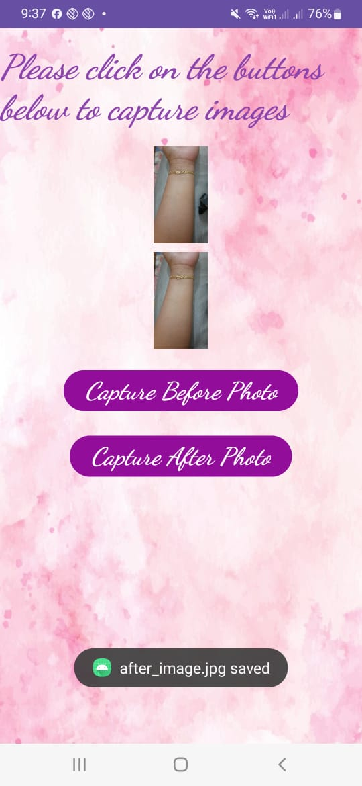

**DISCUSSION**

1.1 **Login and Signup Page**: The initial authentication screen, where new users can create an account and existing users can log in to access the app.

1.2 **Home Page -> Skin Type Routine -> Questionnaire**: From the home page, users can begin a skin type routine, completing a questionnaire that helps customize their care plan.

1.3 **Questionnaire Pages -> Final Skin Care Routine Page**: After completing the questionnaire, users are directed to a final skincare routine page tailored to their needs.

1.4 **Articles -> Share My Routine -> Home Page**: Users can access beauty-related articles, share their routine, and return to the home page.

1.5 **Cosmetic Products (Daytime or Nighttime Routine) -> Questionnaire -> Final Routine**: Users select either a daytime or nighttime cosmetic routine, answer questions, and receive a customized plan.

1.6 **View Recommendation -> Back to Home Page**: This feature allows users to view recommendations and then return to the home page.

1.7 **Haircare Routine -> Ayurveda -> Questionnaire**: Users opting for an Ayurvedic haircare routine complete a questionnaire for a tailored plan.

1.8 **Recommended Ayurveda Products -> Final Hair Care Routine -> Articles**: Based on the questionnaire, users receive Ayurvedic product recommendations and can read related articles. Users receive Ayurvedic product suggestions that avoid specified allergens (e.g., henna).

1.9 **Recommended Ayurveda Products -> Final Hair Care Routine -> Articles**: Based on the questionnaire, users receive Ayurvedic product recommendations and can read related articles. Users receive Ayurvedic product without allergic filter .The change in the cost can been seen in recommended ayurveda products

1.10 **Share Routine -> Back to Home Page**: Users can share their customized routine and return to the home page.

1.11 **Cosmetic Products -> Questionnaire -> Recommended Products -> Final Hair Care Routine**: For cosmetic haircare routines, users answer questions to receive product recommendations and a final plan.

1.12 **Articles -> Capture Image for Feedback**: Users can read articles and capture images to track feedback, utilizing the file system for secure storage of these images

**SNAPSHOTS OF DATABASE AND TABLES**

**DATABASE TABLE (USER AUTHENTICATION )**

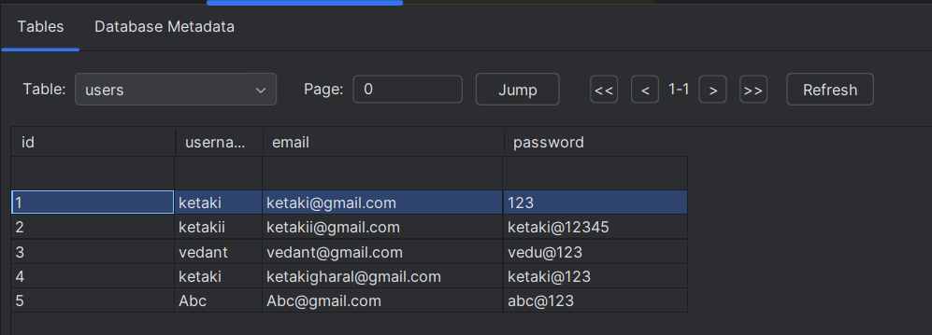

**BEFORE IMAGE**

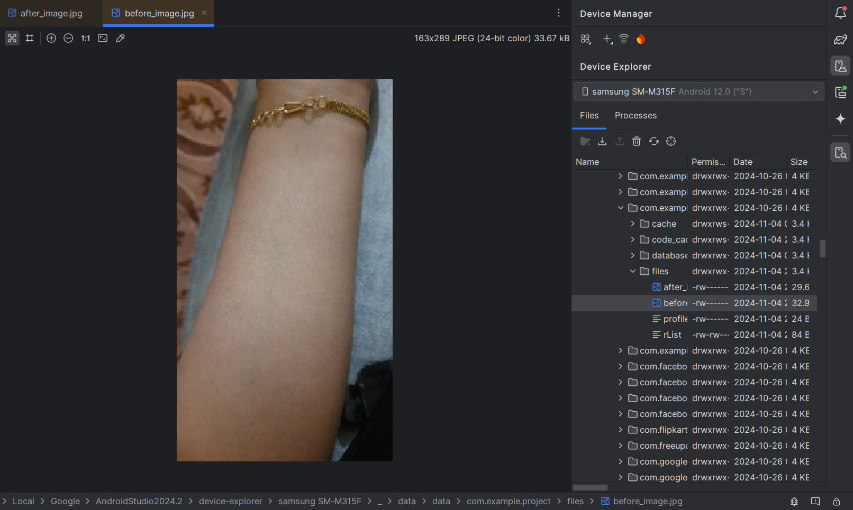

**AFTER IMAGE**

